49085266 - Personalised Multimodal Study Agent

1. Introduction
Problem: Generic chatbots can produce fluent answers, but they are weakly grounded in a student’s own lecture PDFs, slide diagrams, notes and weak topics. In revision, useful answers should cite exact pages, show the original slide image, and support follow-up questions without restarting the whole plan. This makes the project a systems question: can retrieval, representation, state and orchestration improve grounded study support?
Research question and hypothesis: Does combining page-level slide grounding, hybrid multimodal retrieval and agentic branch memory improve grounded revision answers over a plain LLM and text-only RAG? I hypothesise that the final agent improves Recall@k, Page Recall@k and answer-success proxy, especially for cross-modal slide search and branch-style follow-up questions.
2. Knowledge Base Construction
• Data: lecture PDFs, Markdown/text notes, images/screenshots and CSV tables, organised under data/courses/INFS4205 with a configurable SQLite DB path.
• Personalisation: user profile, weak topics, conversation sessions, branch references and course-specific files rather than a public corpus.
• Modalities: slide text chunks, rendered slide images, OCR/caption anchors and metadata, including week, source, page, topic, visual type and index name.
• Granularity: each PDF page is represented as both text and image evidence, so cited ranges such as p.25-p.29 can display the original slides under the relevant answer paragraph.
The final corpus contains 9 lecture documents and 1017 evidence records, including 509 slide-text and 508 slide-image records. (Appendix A)
Example system case: For the mixed-language query “What exactly is the difference between a retriever and a reranker?”, the system retrieves Week 8 Reranker slides p.25-p.29, places slide cards under the cited paragraph, and lets the user open each page for a page-specific explanation.
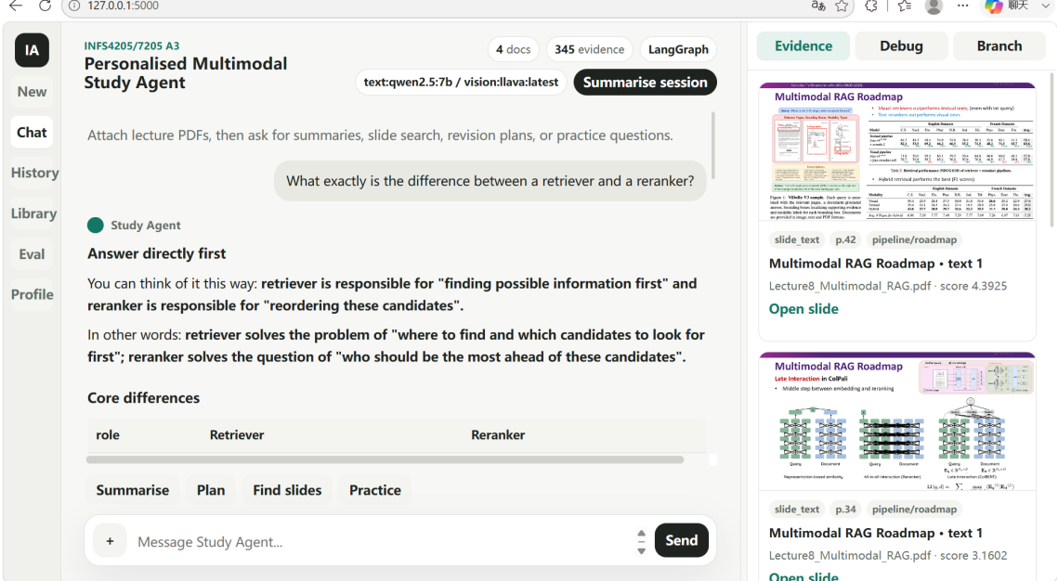
Figure 1. User-facing screenshot.
3. Retrieval and Representation Design
Representation: Each evidence item stores text tokens, a text vector, a lightweight visual-signature vector, OCR/caption text and structured metadata. The logical indexes are text_index, visual_caption_index and table_index. Retrieval combines BM25-style keyword scoring, text-vector similarity, visual/caption similarity and metadata boosts, then applies Reciprocal Rank Fusion over keyword, text, visual and metadata rankings.
Design alternatives: plain_llm removes retrieval; text_only tests lecture text; caption_only tests slide-image OCR/caption evidence; no_visual removes image evidence; no_router removes task-specific routing; no_rerank removes RRF; no_memory removes personal state; final_agent combines all components.These variants isolate the effects of retrieval, visual evidence, routing, fusion and memory rather than only demonstrating screenshots.
• VectorDB/metadata: SQLite stores vectors and metadata; FAISS IndexFlatIP is used for vector ranking when available.
• Multimodal representation: text chunks answer definitions; slide images preserve diagrams, tables and layout; OCR/caption bridges text queries to visual pages.
• Ranking/fusion: RRF improves robustness when BM25, vector scores and visual/caption evidence disagree.
- Agent Workflow
The router selects overview, slide-search, comparison or branch-QA mode, so each query uses a different retrieval and answer strategy rather than the same fixed prompt.
The LangGraph pipeline: load profile → resolve follow-up → classify intent → retrieve evidence → verify grounding → generate answer → update memory → persist session. Routing matters because document overview needs reading-order coverage, slide search needs image evidence, comparison needs focused concept retrieval, and branch questions need local context from previous evidence. The agent therefore coordinates tools, states and verification steps that a one-shot RAG chain cannot handle cleanly.
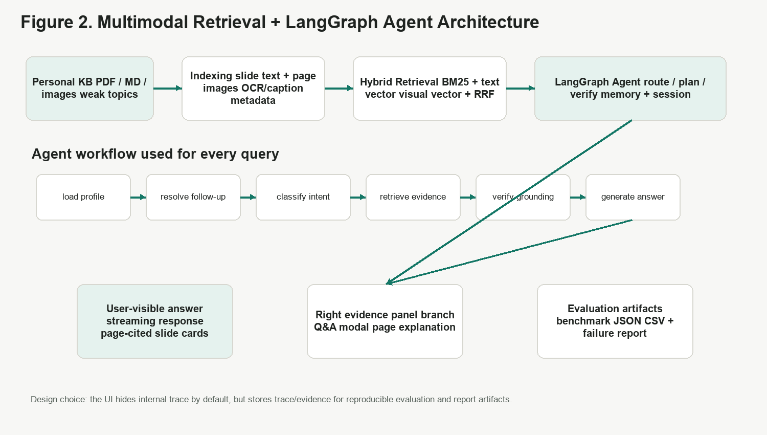
Figure 2. Architecture and workflow.

The top row maps personalised course data to indexing, hybrid retrieval and the LangGraph agent. The bottom row shows the query-processing states. The figure summarises the main technical components: vector/metadata retrieval, multimodal representation, separate indexes, OCR/caption indexing, routing, memory/state and verification.
System component summary
Table 1 System component summary.
Component | Implementation evidence
Retrieval component | vector DB/metadata, multimodal representation, separate indexes, OCR/caption, hybrid retrieval, RRF
Agent framework | LangGraph routing, retrieval planning, memory/state, tool selection, task decomposition, verification
User experience | GPT-style streaming chat, history sessions, branch Q&A, slide cards under cited paragraphs

5. Experimental Setup
Benchmark: Eight queries cover four families: factual retrieval, cross-modal retrieval, analytical multi-hop synthesis, and personalised follow-up/revision planning. Expected keywords, target pages, source hints and modality requirements are stored in data/evaluation/benchmark_cases.json. Full benchmark cases are listed in Appendix B.
Metrics: Recall@k measures keyword coverage; Page Recall@k checks exact slide-page grounding; MRR measures ranking quality; answer-success proxy checks expected concept coverage; latency and tool calls measure efficiency. The evaluation endpoint writes evaluation_results.json, evaluation_summary.csv and failure_cases.md, supporting reproducible quantitative evidence.
6. Results and Analysis
Table 2 Ablation results across system variants.
Variant | R@k | Page Recall | MRR | Answer Proxy | Latency ms
plain_llm | 0.0 | 0.0 | 0.0 | 0.025 | 0.0
text_only | 0.627 | 0.43 | 1.0 | 0.627 | 24.5
caption_only | 0.723 | 0.603 | 1.0 | 0.723 | 13.9
no_visual | 0.723 | 0.553 | 1.0 | 0.723 | 22.5
no_router | 0.627 | 0.38 | 1.0 | 0.627 | 36.1
no_rerank | 0.61 | 0.371 | 0.917 | 0.61 | 28.0
no_memory | 0.627 | 0.38 | 1.0 | 0.627 | 36.5
final_agent | 0.748 | 0.553 | 1.0 | 0.748 | 30.6

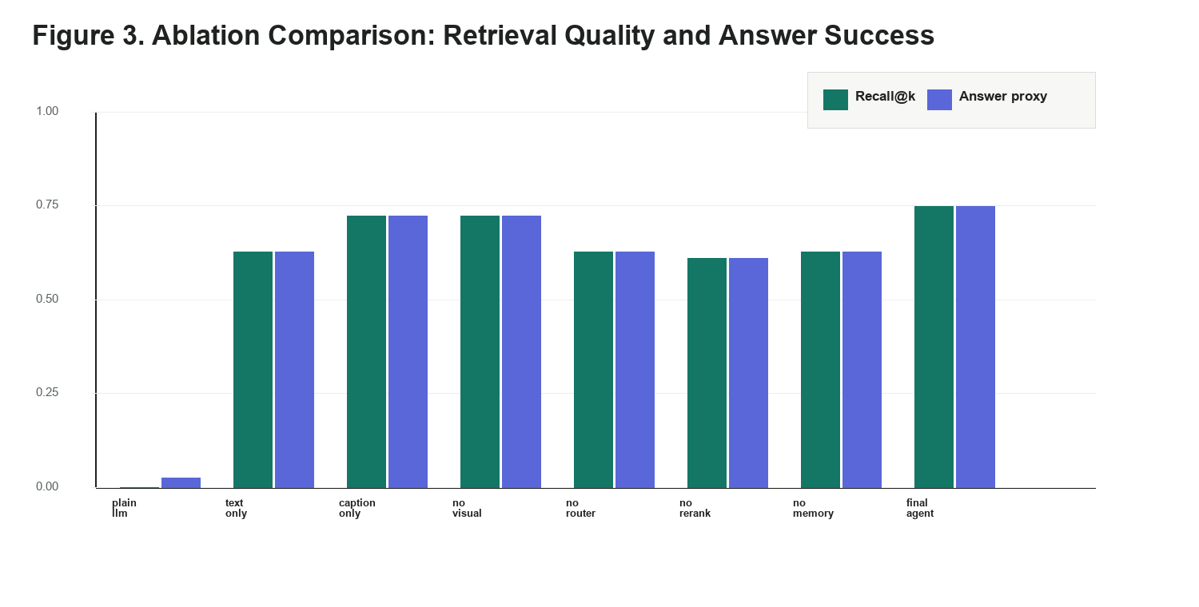
Figure 3. Ablation plot.
The results support the main hypothesis. final_agent achieves the strongest Recall@k and answer proxy, while plain_llm fails on grounded retrieval because it cannot access the course corpus. The drop in no_rerank shows that RRF helps stabilise ranking when different retrieval signals disagree. caption_only is competitive because lecture slides contain rich OCR/caption anchors, but final_agent is more general across factual, visual, analytical and personalised query families. However, caption_only has higher Page Recall than final_agent, showing that OCR/caption anchors are strong for slide-page matching but less general for full agent interaction. Key finding: final_agent reaches Recall@k=0.748 and Answer Proxy=0.748, outperforming text_only (0.627), no_router (0.627), no_rerank (0.610) and no_memory (0.627). The gap between no_router and final_agent shows that retrieval planning matters; the gap between no_rerank and final_agent shows that RRF improves ranking stability; the gap between plain_llm and retrieval modes shows why grounding is essential.
Trade-off: The final agent is slower than caption_only, but still practical in the retrieval benchmark (30.6 ms without optional LLaVA generation). The extra cost supports page evidence, personalised state, branch handling and verification, which are important for revision-oriented interaction.
7. Failure Cases
Failure analysis is recorded in Appendix C. The weakest cases are personalised_revision_plan (Recall@k=0.4) and personalised_branch_followup (Recall@k=0.6, Page Recall=1.0). These are not simple retrieval failures: planning queries require broad cross-lecture coverage, while branch questions retrieve the correct pages but need concise local context. Dense visual slides may also fail when OCR/caption anchors are insufficient.
- Retrieval failure: ambiguous week or lecture references can retrieve nearby but incorrect pages.
- Representation failure: the current visual vector is lightweight; CLIP/OpenCLIP/ColPali could improve true image semantics.
- Orchestration failure: broad revision plans need coverage-aware retrieval, not only top-k similarity.
- Reasoning/display failure: if the answer cites a page range but the evidence list misses one page, the UI cannot show every slide; the fix is coverage-aware page expansion after retrieval.
- Conclusion

Overall, the project shows that a study chatbot is not improved by generation alone. In my system, the main gains come from combining page-level evidence, multimodal indexing, routing and lightweight memory, then checking these choices through ablation results.
Appendix A. Knowledge Base Statistics and Metadata Examples

A1 Corpus statistics
Current indexed corpus, from `/api/status` and the local SQLite database (`data/study_agent_runtime_v2.sqlite`):

- Documents: 9
- Evidence chunks: 1017
- Evidence by modality: 509 `slide_text` records and 508 `slide_image` records
- Modalities: PDF slide text, rendered slide images, OCR/text anchors, visual captions, metadata
- Main course folder: `data/courses/INFS4205`
- Runtime database currently used: `data/study_agent_runtime_v2.sqlite`
- Configurable database path: `STUDY_AGENT_DB_PATH`
- Configurable course folder: `STUDY_AGENT_COURSE`,`STUDY_AGENT_DATA_DIR`

Indexed documents:
Document | Pages | Evidence records
Lecture8_Multimodal_RAG.pdf | 65 | 130
WK7_T6_Slides.pdf | 33 | 66
Lecture7_Token_Reduction.pdf | 48 | 97
Lecture6_High_Dimensional_Indexing.pdf | 26 | 52
Lecture2_Multimodal_Embedding.pdf | 68 | 136
Lecture3_Self-supervised_Multimodal_Embedding_1_.pdf | 67 | 134
Lecture4_Multimodal_Alignment.pdf | 60 | 120
Lecture5_MultimodalLLM_1_.pdf | 76 | 152
Lecture10_Agents.pdf | 65 | 130

A2 Metadata schema
Each indexed evidence record stores:
Field | Purpose
document_id | Links evidence to uploaded file.
source | Original filename, e.g. Lecture8_Multimodal_RAG.pdf.
page | Slide/page number for page-level grounding.
modality | slide_text, slide_image, note_text, uploaded_image, or table.
title | Slide title or inferred chunk title.
content | Text chunk, OCR anchor, or visual caption.
image_path | Rendered slide image path for visual grounding.
tokens_json | Keyword/token representation.
vector_json | Text vector representation.
metadata_json | Week, source type, OCR text, caption, topics, visual type, index name, and visual vector.

A3 Representative indexed record
Representative record type:
{
"source": "Lecture8_Multimodal_RAG.pdf",
"page": 28,
"modality": "slide_image",
"title": "Reranker in RAG - visual page",
"content": "Slide image evidence ... RRF ... combines ranked lists ...",
"metadata": {
"source_type": "pdf_page_image",
"topics": ["RAG", "Reranker", "RRF"],
"visual_type": "pipeline/roadmap",
"index_name": "visual_caption_index"
}
}
This record demonstrates multimodal grounding: the answer can cite p.28, show the original slide image, and explain its relevance to the user's question.

Appendix B. Benchmark Queries and Expected Evidence

B1 Eight benchmark queries
The benchmark is stored in:
data/evaluation/benchmark_cases.json
Case ID | Required family | Benchmark query | Expected evidence / modality
factual_w8_naive_rag_failures | Factual retrieval | What are the three failure types of Naive RAG in Week 8? Explain them and cite the slide page. | Lecture8_Multimodal_RAG.pdf, p.8; expected keywords: broken chunks, irrelevant documents, wrong conclusions; modality: slide_text and slide_image.
factual_w8_bm25_hybrid | Factual retrieval | Explain what BM25, embedding retrieval, and hybrid search solve in RAG. | Lecture8_Multimodal_RAG.pdf, p.17-p.22; expected keywords: BM25, embedding, sparse retrieval, dense retrieval, hybrid search; modality: slide_text.
cross_modal_reranker_slide | Cross-modal retrieval | Find the slide image about reranker or RRF and explain where it sits in the RAG pipeline. | Lecture8_Multimodal_RAG.pdf, p.25-p.29; expected keywords: reranker, RRF, reciprocal rank fusion; modality: rendered slide_image plus caption/OCR text.
cross_modal_token_reduction_visual | Cross-modal retrieval | Find Week 7 slide images about Vision Transformer or token reduction and summarise the visual workflow. | Lecture7_Token_Reduction.pdf, p.5-p.12; expected keywords: Vision Transformer, token reduction, self-attention, pruning, merging; modality: rendered slide_image.
analysis_retriever_vs_reranker | Analytical / multi-hop synthesis | Compare retriever and reranker using Week 8 RAG evidence. | Lecture8_Multimodal_RAG.pdf, p.25-p.29 and related roadmap slides; expected keywords: retriever, candidate evidence, rerank, RRF; modality: multi-slide text/image evidence.
analysis_multimodal_rag_vs_text_rag | Analytical / multi-hop synthesis | Why is Multimodal RAG harder to design and evaluate than text-only RAG? | Lecture8_Multimodal_RAG.pdf, p.30-p.32 and p.42-p.47; expected keywords: image, table, layout, visual evidence, evaluation; modality: text plus visual slide evidence.
personalised_revision_plan | Conversational follow-up / personalised context | Create a 3-day revision plan based on my weak topics and uploaded lecture materials, focusing on RAG and token reduction. | Cross-document evidence from Week 7 and Week 8 plus weak-topic memory; expected output: personalised plan rather than a single retrieved fact.
personalised_branch_followup | Conversational follow-up / personalised context | I do not understand the Day 2 reranker part. How are retriever and reranker different? Do not rewrite the whole plan. | Previous plan state plus Lecture8_Multimodal_RAG.pdf, p.25-p.29; expected behaviour: local branch answer with lightweight memory.
It contains eight cases across four required query families:

B2 Expected keywords/pages/modalities

Each benchmark case specifies:

- expected_keywords
- expected_pages
- expected_source_hint
- requires_visual
- top_k

B3 Metric definitions
Metric | Definition
Recall@k | Fraction of expected keywords found in top-k evidence.
Page Recall@k | Fraction of expected pages retrieved in top-k evidence.
MRR | Reciprocal rank of the first relevant evidence item.
Answer-success proxy | Keyword coverage in generated/grounded answer plus evidence.
Latency | Milliseconds for the evaluated mode.
Tool calls | Number of retrieval/tool steps used by the mode.

Appendix C. Evaluation Outputs
Required query family | Representative benchmark query | Expected evidence | Observed failure mode | Interpretation and proposed fix
Factual retrieval | "What are the three types of failures in Naive RAG in Week 8? Please explain in Chinese and cite the page numbers." | Lecture8_Multimodal_RAG.pdf, p.8, slide_text and slide_image | If the query only says "Week 8 failure" without "Naive RAG", nearby RAG summary slides can be ranked above the exact p.8 slide. | This is mainly a retrieval ambiguity problem. The fix is metadata-aware filtering by lecture/week plus exact keyword boosting for named slide titles.
Cross-modal retrieval | "Find the slide image that explains RRF / reranker in RAG." | Lecture8_Multimodal_RAG.pdf, p.25-p.29, especially p.28-p.29, visual slide evidence | Lightweight visual signatures and OCR/caption text can retrieve the right section, but they are weaker than a full CLIP/OpenCLIP/ColPali embedding for visual-only questions. | This is a representation limitation. The current system still returns slide images, but a stronger visual embedding model would improve semantic image matching.
Analytical / multi-step synthesis | "Compare retriever and reranker, and explain why Week 8 says ranking matters." | RAG pipeline slides, reranker slides, RRF slides, and take-home message slides | A naive answer may point to slides instead of first explaining the conceptual distinction. | This is a generation/orchestration problem. The implemented fix is an intent-specific comparison answer: first answer directly, then cite p.25-p.29/p.42 evidence and show related slides under the relevant paragraph.
Conversational follow-up / personalised context | "Day 2: Reranker—I don’t understand this part. How do you distinguish between a retriever and a reranker? Don’t rewrite the entire plan." | Previous revision-plan state plus Week 8 reranker evidence | The system may over-rewrite the full plan or ignore that the user is asking a branch clarification. | This is an agent-state problem. The fix is lightweight session/branch memory: treat the question as a local clarification, keep the original plan intact, and store the branch question as a low-weight reference.

